8 channel DTMF controller manual
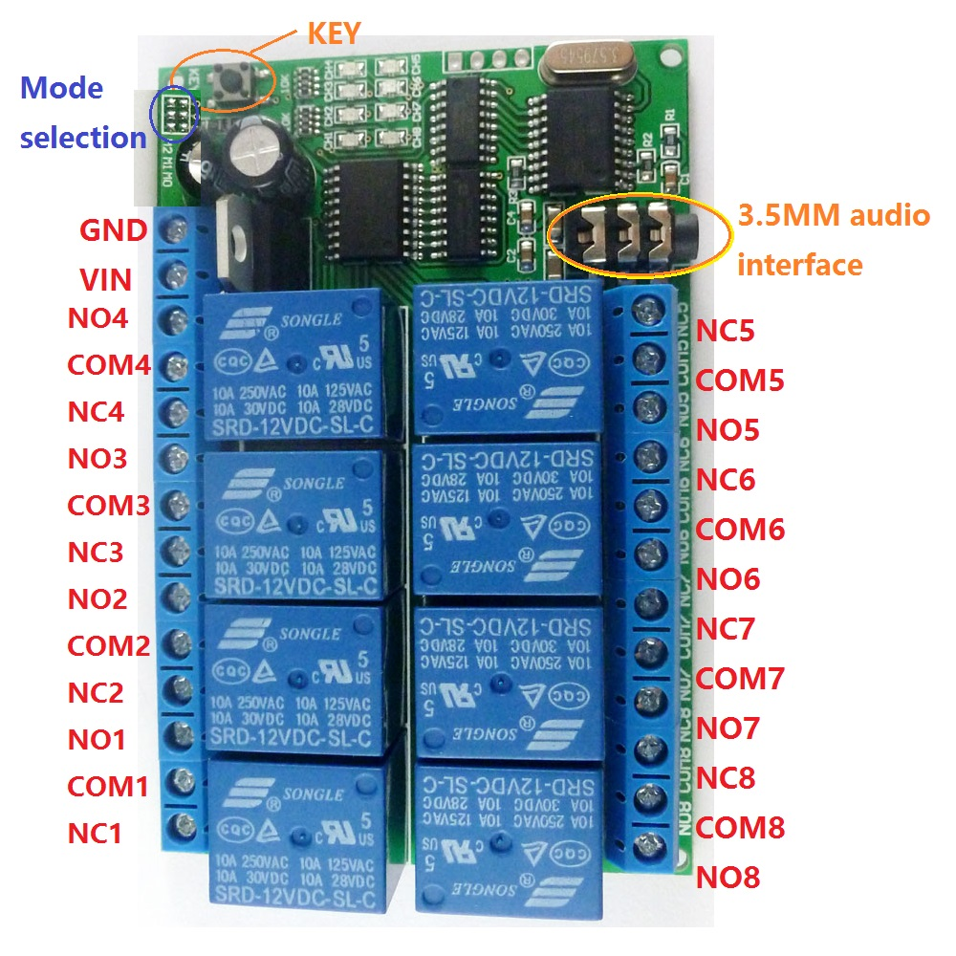
Operating Video : https://youtu.be/EWpK11c7WKk
Functional characteristics:
1 Product model: AD22A08
2.working voltage DC 12V, with reverse polarity protection
3.Operating Current: Standby 11-13 MA, 1 relay "open" 44MA, 2 relays "Open" 77MA, 3 relays "Open" 110MA, 4 relays"open" 140MA, 5 relays open 170MA,6 relays open 197MA,7 relays open 223MA,8 relays open 247MA.

4 eight modes of operation:Non-locking (Momentary ), self-locking (Toggle),inter-locking (Latch), 5/20/60/120/250-second delay
5 The default control command is 1/2/3/4/5/6/7/8.Example: Dial 1 to control relay 1, dial 2 to control relay 2, dial 3 to control relay 3, dial 4 to control relay 4; control commands can be changed any 1-4 bits. (For more details, refer to " AD22A08_8 channel DTMF controller commands setting manual ").
6 Size: 94 * 62 * 19.5mm
7 Weight: 114 grams
8 Maximum load: 10A / 250VAC, 10A / 125VAC, 10A / 30VDC, 10A / 28VDC, 10A / 12VDC

Use Instructions:
This is the DTMF audio controller with four channels, any phone or fixed telephone with DTMF key code remotely controls product relay "open" and "close".(the majority of smartphones and functions machine are DTMF code). Our software "DTMF Dial" (installed in a computer) can be also provided to control relays.
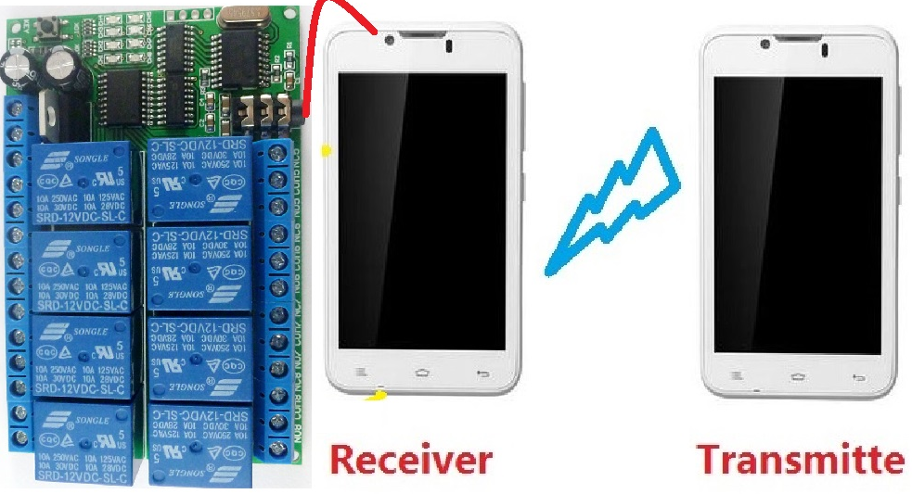
As shown above, by phone remote control relay. You need two phones, one as a receiver (phone_1), the other one as a transmitter (phone_2); mobile phone_1 connected by DTMF audio cable 3.5MM audio controller (the controller to be powered), and then using phone_2 ( may be a fixed telephone) call the phone_1, phone_1 answered, so that two phone call each other; then dial 1/2/3/4/5/6/7/8 by phone_2 keypad to control 8 relays .
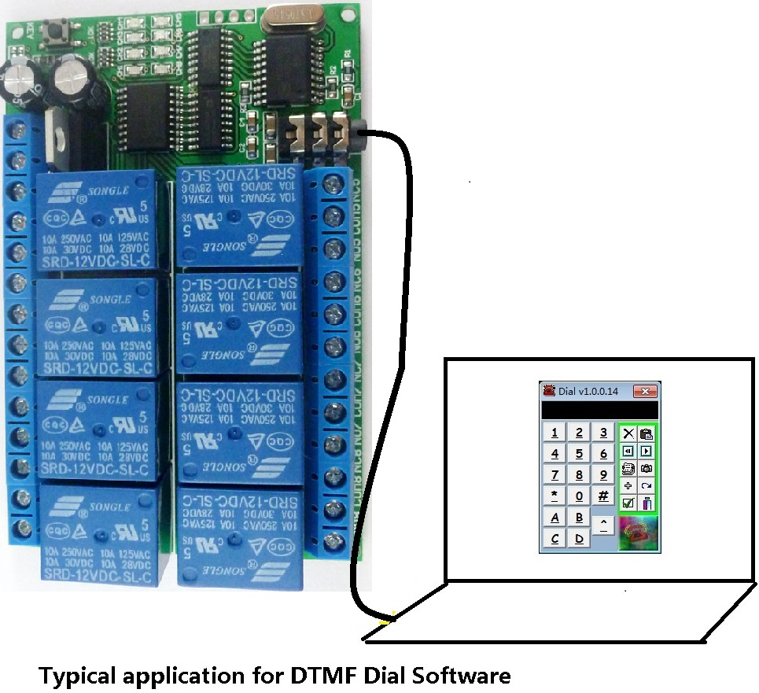

As shown above, you can install one of our "DTMF Dial" software in your computer, through the software control DTMF audio controller. At first, use 3.5MM audio cable to the computer video port and audio port controller, then click on the software to control relays 1/2/3/4/5/6/7/8.

Caution:
1 DTMF audio controller must use stable work of DC 12V power supply (recommendations 2A or above the power adapter)
2 remote control the controller by a mobile phone, the receiver must be the phone with 3.5MM audio interface, the transmitter can be a cell phone or landline
3 as a receiver of the phone or a computer installed the "DTMF Dial" software must output a sound (not muted), or they will not control relays.
Glossary:
NO: Normal open
COM: Common terminal
NC: Normal Connect
Relay open: COM connected NO but disconnected NC
Relay close: COM disconnected NO but NC connected COM.
Non-locking (Momentary ): Dial 1 (2/3/4 is the same), relay 1 "Open", relay close after 1 second delay
Self-locking: Dial 1, relay 1 "Open", dial 1 again, relay 1 "off", and so on
Inter-lock: Dial 1, relay 1 "Open", other relays "Off"; dial 2, relay 2 "Open", other relays "off", and so on
"Delay": Dial 1, relay 1 "Open", relay 1 "Close" after a time
Mode selection:
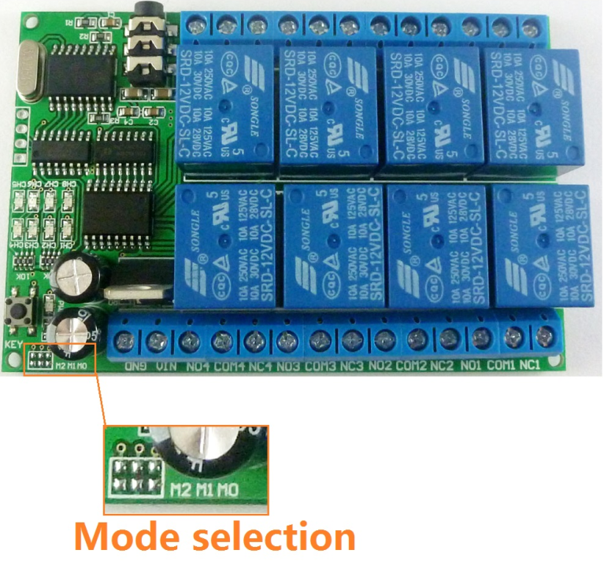
Eight modes of operation, electric iron jumper (picture above) on the pads
Mode selection  （M0 M1 M2) |  | Function | Illustrate
 | Mode 0 | (Default mode)  Non-locking (Momentary ) | Relay open for 1 second
 | Mode 1 | self-locking (Toggle) | Relay open->Relay close  Relay close-> Relay open
 | Mode 2 | Inter-locking (Latch) | The current channel relay open, the other channel relay close
 | Mode 3 | Delay 5S | Relay open for 5 seconds
 | Mode 4 | Delay 20S | Relay open for 20 seconds
 | Mode 5 | Delay 60S | Relay open for 60 seconds
 | Mode 6 | Delay 120S | Relay open for 120 seconds
 | Mode 7 | Delay 250S | Relay open for 250 seconds

Wiring diagram:
1 Control 12V circuit, the wiring as shown below. Load "LOAD" can be LED lights, fans, motors, routers, and other 12V equipments
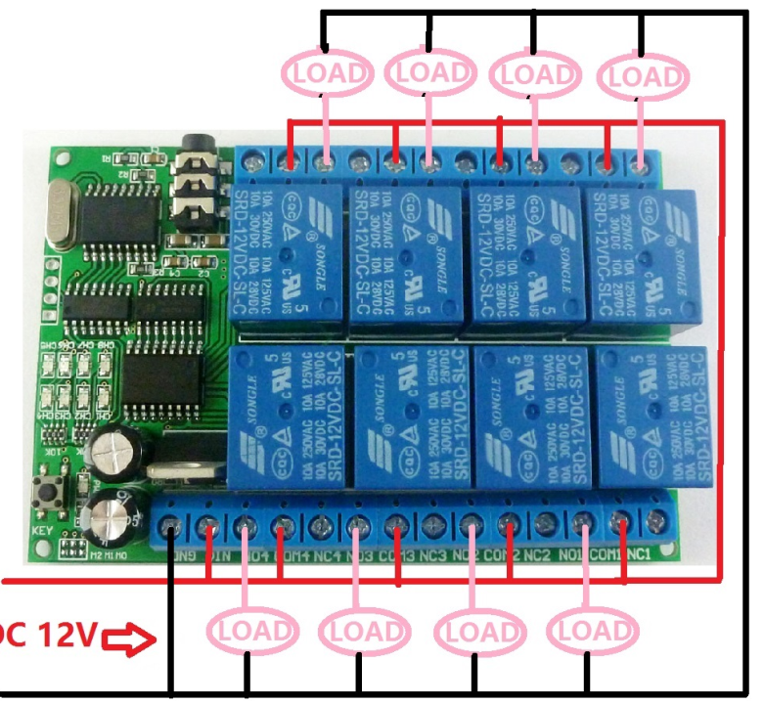

2 DC 1-110V or AC 85-265V circuit, the wiring is shown below. Load "LOAD" can be LED lights, fans, motors, and other kinds of voltage AC and DC equipments.
